2022 Preble SWCD Big Tree Contest
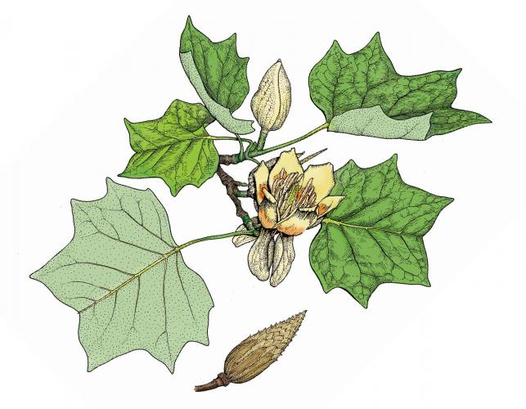
Is your Tulip Poplar the biggest in Preble County? Enter in
Preble Soil and Water Conservation District’s contest to find out!
Contest Rules-
For our first annual Big Tree Contest, we have selected the Tulip Poplar (Liriodendron tulipifera), also known as Yellow Poplar or Tuliptree. This monumental species is the largest tree in the Eastern U.S., and combines beauty, ecological importance, and timber value.
Competing trees must be located within Preble County. If the tree is located on property not owned by the nominator, permission must be obtained from the landowner to enter the tree into the contest.
The landowner will be awarded if the tree is declared the winner.

Forms must be submitted to Preble SWCD at 2789 US RT 35 E, West Alexandria, OH 45381. In addition to mail or drop-off, online submissions may also be emailed to District Educator Savannah Ballweg at sballweg@prebleswcd.org . Forms must be completed entirely. Additional information such as maps, GPS coordinates, and pictures are useful but not required. If a tree is nominated multiple times, the first submission will be the entry used in the contest. Top ranking submissions will be visited for measurement verification by qualified personnel to determine the winner.
The deadline for submissions is Friday, December 9th 2022.
The winner of the contest will receive a commemorative plaque made from Tulip Poplar wood!
1st Annual Big Tree Competition
Tulip Poplar Identification Tips
- Tulip Poplars are very large trees at maturity. It is not uncommon for them to reach 100 feet in height. One tree named “Fork Ridge Tulip Tree” in the Great Smoky Mountains National Park has been recorded at 191.9 feet tall!
- Growth rate is fast for this species, with some gaining two feet or more per year
- Trunks are typically straight, with grayish brown bark and deep, long ridges. Young trees have smoother gray bark with white streaks
- Leaves have a unique shape, with a flattened top, and two pointed lobes on the lower portion of the leaf near the stem
- Flowers arrive in early summer, and are yellow with orange splotches inside the blooms. The papery clusters of seeds from the flower will remain on the branches into the winter
- Buds begin green then turn red-brown, and have a flattened shape resembling a duck bill
- Tulip Poplars are often some of the oldest trees in their forest stands because they are a pioneer species that can grow quickly after disturbances eliminate other trees (like logging, fires, and tornados). They require high sunlight levels to be successful, but are less specific when it comes to soil characteristics and can tolerate a range of soil types
- Fun Facts- Tulip Poplars have many names, including popular ones like Yellow Poplar and Tulip Tree, but also less commonly Whitewood, Canoe Tree, and Fiddlewood. Though the word “poplar” is in their name, these trees are not in the Poplar Family. They are actually a member of the Magnolia Family!

Have ID questions? Call the office at (937)456-5159 or email Savannah Ballweg at sballweg@preblewcd.org !

