1st Annual Big Tree Competition
Tulip Poplar Nomination Form
Tree Information
Circumference of tree measured at 4.5 feet high (inches)-___________ Rough estimate of tree height (feet)-_____________
Address of Tree-_____________________________________________________________________________________________
Location Description-_________________________________________________________________________________________
____________________________________________________________________________________________________________
Additional Details (optional)-___________________________________________________________________________________
____________________________________________________________________________________________________________
Nominator Contact Information
Name of Nominator-______________________________________________Phone Number-______________________________
Address of Nominator-_______________________________________________________________________________________
Owner Contact Information (Only complete if nominator contact info is different from owner contact info)
Name of Owner-_________________________________________________Phone Number-_______________________________
Address of Owner-___________________________________________________________________________________________
Submit by December 9th, 2022 to 2789 US RT 35 E, West Alexandria, OH 45381 or email sballweg@prebleswcd.org
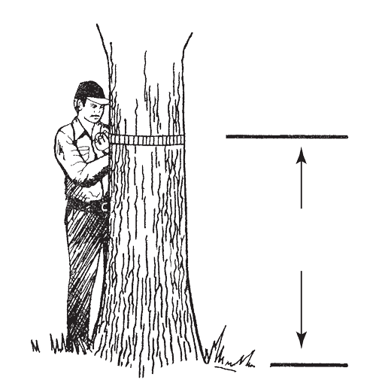
4 Feet, 6 Inches Tall

Tulip Poplar Identification- https://ohiodnr.gov/discover-and-learn/plants-trees/broad-leaf-trees/tuliptree-liriodendron-tulipifera
Ohio State Champion Trees- https://ohiodnr.gov/discover-and-learn/safety-conservation/about-ODNR/forestry/champion-trees/native-champion-trees
More tree identification materials can be found on our website- http://www.prebleswcd.org/forestry-resources.html

